When Asteroids Attack - An Introduction to SEE to Develop Student Interest in HLA

Bingyang Wei∗, Amy Knowles, Christopher Silva, Christine Mounce

Department of Computer Science

Midwestern State University,

Wichita Falls, Texas 76308

∗Email: [bingyang.wei@mwsu.edu](mailto:bingyang.wei@mwsu.edu)

**Abstract**

The Simulation Exploration Experience (SEE) is an annual, inter-university, distributed simulation challenge led by NASA. A primary objective is to provide a platform for college students to work in highly dispersed teams to design, develop, test, and execute a simulated lunar mission using High Level Architecture. During the SEE in 2016, 19 federates developed by student teams from three continents successfully joined the federation and collaborated to accomplish a lunar mission. The MWSU team first participated in SEE 2016 by developing a communication satellite federate which broadcast an alert about the incoming of an asteroid to physical entities on the surface of the moon. This paper describes SEE, High Level Architecture, the NASA and other team federates, the MWSU Sim Team experience, lessons learned and recommendations for future teams.

1. INTRODUCTION

Modeling and Simulation (M&S) is the representation of the behavior or characteristics of one system, such as the moon, through the use of another system, which in our case is a diverse group of computer programs designed under the High Level Architecture (HLA) standard. Simulations allow us to view and explore the behavior of a system that may be too expensive or too risky to explore in the real world. Interest in M&S has increased greatly over recent years, in part due to the following reasons:

* Simulations are generally less expensive, and far safer than real-world experiments (ex. supercomputer simulations of nuclear explosions)
* Simulations can be more immersive than attempts at real-world experiments (ex. simulations of surface conditions of nearby planets in preparation for future NASA missions)
* Simulations can be performed faster than real-time (ex. weather simulations)

Although interest in M&S has greatly increased over recent years, there is still a lack of undergraduate level programs focusing on the design and implementation of simulation. As M&S is quickly becoming a multi-billion-dollar industry, a highly skilled workforce is required. In order to develop this workforce, modeling and simulation programs need to be developed starting in public school and ranging all the way through graduate level studies. Although programs exist at the master’s level and above, few programs exist at the undergraduate level [4]. The SEE program is an excellent introduction to distributed simulation as it provides faculty advisors and students with the needed elements: content, software, tools, systems, mentoring, along with project management support in an attempt to expand M&S undergraduate level education.

Initiated in 2011, the annual Simulation Exploration Experience event, formally known as SISO (Simulation Interoperability Standard Organization) Smackdown, has successfully promoted the awareness of the use of HLA in distributed simulation around the world. During the event, academia, industry and professional associations collaborate to design, develop, test and demonstrate a simulated lunar mission. SEE provides an excellent platform for college students to learn and practice both M&S and software engineering concepts and principles. More importantly, the opportunity of working closely with M&S professionals in industry and associations is an invaluable experience to the students.

SEE originated with NASA engineer Zack Crues and has been implemented annually since 2011 by NASA and the SISO Space Community Forum. It was developed as a way engage students in modeling and simulation, an area of education almost non-existent at the undergraduate level. Because SEE involves geographically distributed inter-university teams, it proves to the participants that interoperability and standards matter in order to allow distributed parts of the simulation to work seamlessly. This program allows students to learn HLA in a fail-free environment with expert and peer support, to learn employer expectations first-hand, as well as allow them to assess their interest and aptitude for a career in M&S.

This paper concentrates on the learning experience of MWSU team members, their interactions with other student teams across the world, industry representatives from Pitch, VT MÄK, and NASA engineers at both Johnson Space Center and Kennedy Space Center. The rest of the paper is structured as follows: Section II provides an introduction to HLA; Section III describes in detail the 2016 experience of the MWSU team; Lessons learned from SEE are discussed in Section IV and Section V concludes the paper and provides instructions for future teams to join SEE.

1. HIGH LEVEL ARCHITECTURE

High-Level Architecture is an architecture that allows many distributed simulation systems to work together seamlessly. There are five parts to a HLA system:

* Runtime Infrastructure (RTI) - Software that provides HLA services. (ex. Pitch’s pRTI and VT MÄK’s MÄK RTI)
* Federate - A simulation system that connects to the RTI.
* Federation Object Model (FOM) - A description of data exchanges in a federation.
* Federation - All of the federates along with the RTI and the FOM they use.
* Federation Execution - An instance of the federation.

HLA uses a publish/subscribe methodology for information services. This means that a federate “publishes” certain data and "subscribes" to other data. To publish data a federate sends it to the RTI. To receive subscribed data a federate will receive a callback from the RTI anytime the subscribed data is updated.

The FOM contains descriptions of the Objects, Interactions, and Data Types that federates will use in a federation. Because of this all federates must agree on which FOMs to use. This is arguably the most important part of the HLA standard; it ensures that the designers of each federate communicate in order to come to an agreement on not just the FOMs, but on other aspects such as the overall goal of the simulation.

The recommended representation for a federation is called a “lollipop” diagram (see Figure 1).

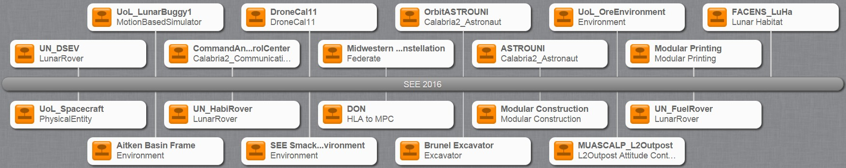

Fig. 1: SEE 2016 participant’s lollipop diagram.

1. 2016 SEE EXPERIENCE

The Simulation Exploration Experience, hosted by NASA is an exciting and immersive experience in modeling and distributed simulation. The 2016 MWSU Sim team consisted of four computer science students, one graduate and three undergraduates, and our sponsoring professor and local HLA expert, Dr. Bingyang Wei. We began meeting formally late in the Fall 2015 semester in preparation for our participation in the SEE 2016 workshop at the 2016 SCS Spring Simulation Multi-Conference (SpringSim ’16) that took place in Liverpool, England. This experience allowed us to implement knowledge learned in multiple courses, such as software engineering, discrete system simulation, and contemporary programming.

Our first step in preparing ourselves for writing our own federate was to download the HLA tutorial available on the Pitch website [1]. Once we fully understood the HLA model, we were able to access and complete numerous tutorials on creating federates available to participating SEE team members in the SEE Assembla repository. The following subsections describe the MWSU Sim team satellite federate, and the team’s experiences interacting with industry professions, NASA engineers, and college students from around the world.

1. *Satellite Constellation & Lunar Visualization Module*

The Satellite Constellation & Lunar Visualization module first propagates and then renders satellite constellations. The Systems Tool Kit’ (STK) numerical propagator is invoked to generate the orbits of different satellites. The constellation is achieved by STK’s High Precision Orbit Propagator (HPOP) which is a part of the Orbit Propagation Library (OPL). By numerically integrating the various forces affecting satellites, HPOP brings high fidelity orbit propagation into our communication satellites.

When the whole federation is running on Pitch RTI, a 6-satellite constellation is designed over Aitken Basin to maximize the time each satellite is in view of the surface entities as shown in Figure 2.

The architecture of the Satellite Constellation & Lunar Visualization module is shown in, Figure 3, a UML class diagram.

1. *Tag Ups & SpringSim ’16*

Starting in November 2015, the MWSU Sim team participated in weekly *tag ups* which occurred at 09:00 CST (06:00 UTC) every Wednesday. These hour-long meetings utilized a software called VSEE, a visual telecommunication software, that allowed teams from universities around the world, representatives from Pitch and VT MÄK, as well as NASA engineers at both Johnson Space Center (JSC) and Kennedy Space Center (KSC) to communicate and share their progress. As March 2016 approached, the VSEE *tag ups* were used for preliminary connection testing. During these testing *tag ups*, the Pitch RTI was initiated, then the three NASA world origination federates were connected to the RTI. Once the simulated world had been instantiated, each team was asked individually to attempt to connect their federate to the Pitch RTI. Connection of the MWSU satellite federate to the Pitch RTI was performed by first connecting to a VPN, initializing our satellite federate, and upon request from the VSEE meeting organizer, connection to the Pitch RTI.

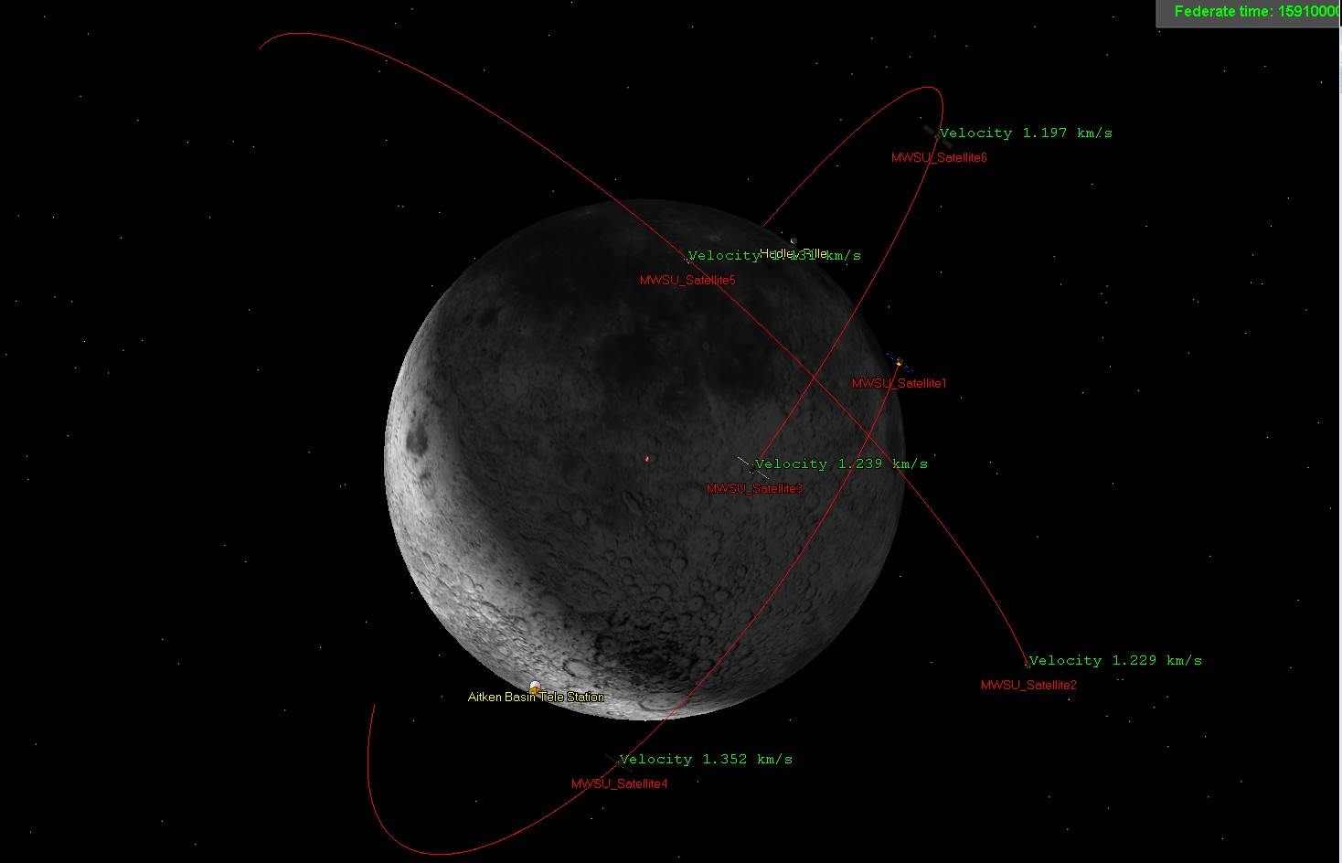

Fig. 2: MWSU communication satellites federate.

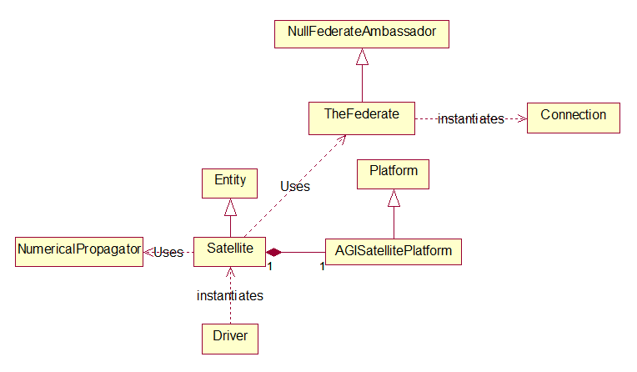

Fig. 3: MWSU satellite constellation & lunar visualization module UML class diagram.

The MWSU Sim team participated in the SEE workshop event of SpringSim ’16 remotely via VSEE. During SEE 2016, a lunar mission was simulated. NASA JSC, KSC and 12 universities from three continents participated in the distributed simulation event. All participants conformed to the IEEE HLA standard 1516-2010 for modeling and simulation. As usual, NASA provided basic support to the entire simulation mission, JSC regulated the time of the simulation while KSC provided real-time visualization of the simulation mission. Each university contributed to the lunar simulation by implementing a federate. A description of the SEE 2016 simulated mission follows: Astronauts explore a huge impact crater close to the south pole of the moon, called Aitken Basin. Viewers are then introduced to a number of new lunar research units and construction sites: a 3D-printing site by University of Alberta (Canada), a supply depot, oxidizer and propellant production facility by University of Bordeaux (France), an astronaut habitat site by Facens (Brazil), a cargo rover by Florida Institute of Technology, a fuel rover by University of Nebraska, a lunar buggy and an unmanned aerial vehicle (UAV) by University of Liverpool (England). The peaceful exploration operation is suddenly interrupted by the detection of an incoming asteroid by an asteroid detection system developed by University of Genoa (Italy). The command and communication center [2] developed by University of Calabria (Italy) alerts all physical entities on the surface of the moon, and the communication satellites developed by MWSU

alert the lunar buggy which is out of reach of the command and control center.

During the simulation, all nineteen federates connected successfully to the runtime infrastructure (RTI) provided by Pitch Technologies and were able to advance time (see Figure 1). Each rectangle represents a joined federate and the middle gray bar denotes the RTI.

1. LESSONS LEARNED

The MWSU federate was able to locate all physical entities in the Insight3D viewer, and verify the location and motion information of different entities in the orbit of the moon or on the surface. During the final testing, we ran into three issues. The strict timing needs of HLA meant that a wired connection was needed to prevent timeouts and disconnects. We were

unable to fix the third issue which was a MÄK RTI exception.

Problem: MWSU federate worked well with Pitch RTI but failed to run on MÄK RTI. When testing on MÄK RTI, exception “unsatisfiedLinkError makRtiJava1516e.dll: the specified procedure could not be found” is thrown.

Solution: MWSU federate is a Java application built in Eclipse. This is an old problem with the MÄK RTI which does not work with the most recent version of the Java JDK. We attempted to downgrade our Java JDK environment/code in order to communicate with the MÄK RTI, as suggested by members of the 2013 UA Huntsville team [3]. We were unable to solve this problem due to time constraints and have informed engineers at VT MÄK. We hope this issue can be fixed for SEE 2017.

1. ADVICE FOR FUTURE TEAMS

The more teams that participate in SEE, the better the experience for everyone involved. If you would like to start a SEE Sim team at your university please visit the [http://www.exploresim.com/team.](http://www.exploresim.com/team)

The requirements to start a team are:

* 1. Minimum team must have at least one college faculty advisor and one student with knowledge of C++ and/or JAVA with the readiness to learn HLA Evolved, use standards and participate in an inter-university international simulation experience.
  2. Teams can consist of a class, independent researchers, a departmental project, an interdepartmental project or inter- university undertaking.
  3. each team should have a team leader responsible for communication with the SEE Operations, Technical and Executive leaders and committees.

The steps to start a team of your own are as follows:

1)Read the requirements necessary to form a team (mentioned above). 2)Fill out and submit the team official interest form.

3)Wait to be contacted by SEE General Manager Stephen Paglialonga.

Once you have a team consisting of at least one faculty advisor and one student willing to learn HLA, in depth study of HLA should begin. The best place to start is to read the HLA Tutorial available at [http://www.pitchtechnologies.com/hlatutorial/.](http://www.pitchtechnologies.com/hlatutorial/) It is our suggestion that a minimum of one month be given to the study of HLA in order to fully understand the infrastructure and intricacy of the system. After everyone on the team has reached some degree of familiarity with the HLA infrastructure, and has acquired access to the SEE team development website, the Assembla Repository will be available. This repository houses not only a fantastic interactive tutorial on creating a federate using Java, but also the Aitkin Basin and Environment federates developed by NASA engineer Zack Crues. These two federates are the cornerstone of the entire lunar mission simulation and are extremely well-commented, making them one of the best learning tools available.

The next step is to decide what meaningful federate to build. Does your team want to create a satellite system to relay information, a giant laser to target incoming asteroids, or a moon buggy to transport researchers around the lunar base? Creating a meaningful federate that will interact cooperatively with federates created by other inter-university teams is vital to the overall experience of SEE. After your team has decided on an idea for a federate, the team needs to decide on application logic: how are you going to create this federate? Are you going to use STK written in Java and Eclipse for visualization? If you do, remember that the MÄK RTI does not yet work well with Java applications. Finally, the team needs to consider how to connect the federate to the federation, as the whole purpose of this exciting exercise is to work with other university students, professional engineers, and industry representatives to develop a distributed simulation.

1. CONCLUSION

In this paper, we described our experience in designing of the MWSU communication satellites federate in SEE 2016. During the 4-month period, students in the development team learned HLA standard, programmed using STK Components, used different RTI software implementations and collaborated with students from other universities. Each team in SEE 2016 demonstrated the capabilities that modeling and simulation can bring to solve difficult problems in a challenging environment, from all across the globe, despite language barriers and time zone challenges. By sharing the experience of the MWSU Student Team in participating to the SEE, we hope to guide new teams to participate the coming year’s SEE event.

REFERENCES

[1]“Hla tutorial,” [http://www.pitchtechnologies.com/wp-content/uploads/2014/04/TheHLAtutorial.pdf,](http://www.pitchtechnologies.com/wp-content/uploads/2014/04/TheHLAtutorial.pdf) accessed: 2016-05-15.

[2]A. Falcone, A. Garro, F. Longo, and F. Spadafora, “Simulation exploration experience: A communication system and a 3d real time visualization for a moon base simulated scenario,” in *Distributed Simulation and Real Time Applications (DS-RT), 2014 IEEE/ACM 18th International Symposium on*. IEEE, 2014, pp. 113–120.

[3]D. Bulgatz, D. Heater, D. A. O’Neil, B. Norris, B. C. Schricker, and M. D. Petty, “Design and implementation of lunar communications satellite and server federates for the 2012 siso smackdown federation,” in *Proceedings of the Fall 2012 Simulation Interoperability Workshop*, pp. 10–14.

[4]C.M. Banks, and M.L. McGinnis, “Compelling challenges and recommended solutions: developing a continuity of M&S education from public school to graduate studies,” in *Proceedings of the 2008 Spring simulation multiconference*, pp.773–780, 2008.